Ethan Allen Eight Runs Dining Set

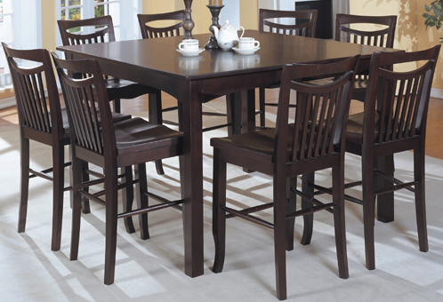

|  |
| --- |
| **DESCRIPTION** |
| Ethan Allen introduces stylish four legged balanced eight chairs which is perfect for stable surrounding. Four long square table legs makes it easy for people sitting to adjust their legs inside the table and the wooden polyester disk which is used above the table is very strong and build to hold weights without expanding. |

|  |  |  |
| --- | --- | --- |
| **Price** | **1500$** | |
| **Dimensions** | **Table H** x **W** x **L** | **54in x 40in x 40in** |
| **Chairs H** x **W** x **L** | **57in x 33in x 33in** |
| **Features** | **The eight chairs which have soft form seat which is very comfortable and has long legs which enables chairs to stay balance even on high pressure.** | |
| **Finished** | **Missile Coat Touch Polished** | |
| **Available in** | **Brown Only** | |